

Streaming Individual Assignment

STREAM PROCESSING & REAL TIME ANALYTICS



May 15, 2020

Mohamed Amer

Table of Contents

1 Introduction 2

2 Connecting to Twitter 2

3 Requesting Steps 2

3.1 Fill the missing parts in the Spark Streaming application. 2

3.2 Connect to the edge machine 2

3.3 In the query from twitter_app.py use different location, word instead of # 3

3.4 Output of top10 elements been computed. 4

3.5 Obtain the Top10 words (not only hashtags) using a moving window of 10 minutes every 30 seconds. 5

4 Bonus points 5

4.1 Use your own Access credentials. 5

4.2 Use Flajolet-Martin algorith to compute an approximation of the TopK words or hashtags. 5

4.3 Connect Spark Streaming with Kafka. 6

# Introduction

Getting data from twitter in almost near real-time has many different use cases. For

instance, a corporation may have the option to automatically track what people are

tweeting about their brand in near real-time. Also, it may be possible to interact

automatically with customers through twitter by developing a bot.

For more information about consuming Streaming Data in twitter, please have a look to

this: https://developer.twitter.com/en/docs/tutorials/consuming-streaming-data.html

In this assignment, we are going to use the OAuth authentication method:

https://developer.twitter.com/en/docs/tweets/filter-realtime/guides/connecting

Although the twitter streaming API has been reported to provide only 1% of all the

tweets (http://www.public.asu.edu/~fmorstat/paperpdfs/icwsm2013.pdf) it is a good

simplification of the full tweets (Firehose), as you can see in the following picture.

# Connecting to Twitter

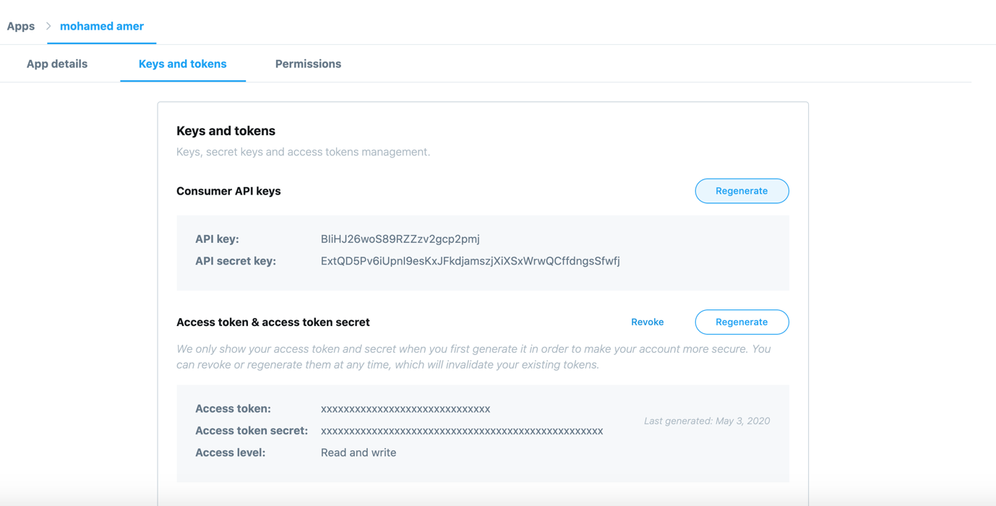

# Requesting Steps

## Fill the missing parts in the Spark Streaming application.

Answer:

Done, and please check attached spark_streaming_twitter.py

## Connect to the edge machine

Connect to the edge machine and upload the files or create them with a text

editor. Please note that you need to change the application port from 9009 to a different one to avoid conflicts with running programs from other colleagues.

Answer: (file 🡪spark_streaming_twitter_hahtags.py)

Locally I run my applications using port 9009, while in ie Cluster I used port **10012** and below is the screen shots from ie cluster:

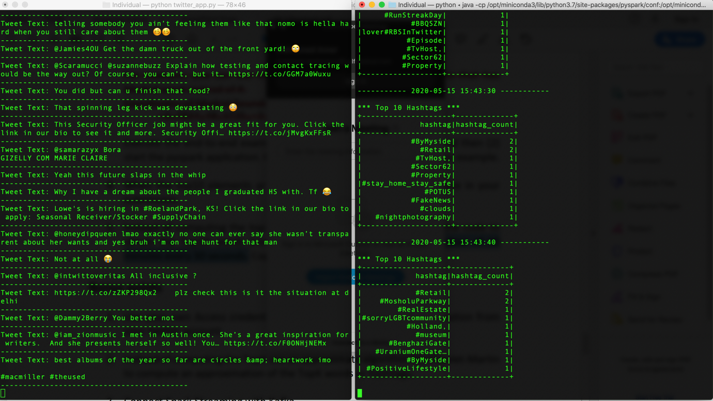

## In the query from twitter_app.py use different location, word instead of #

Answer:

I used Saudi Arabia Bounding Box and was interested to track tweets having the word corona in Arabic “كورونا” and the below is what I got

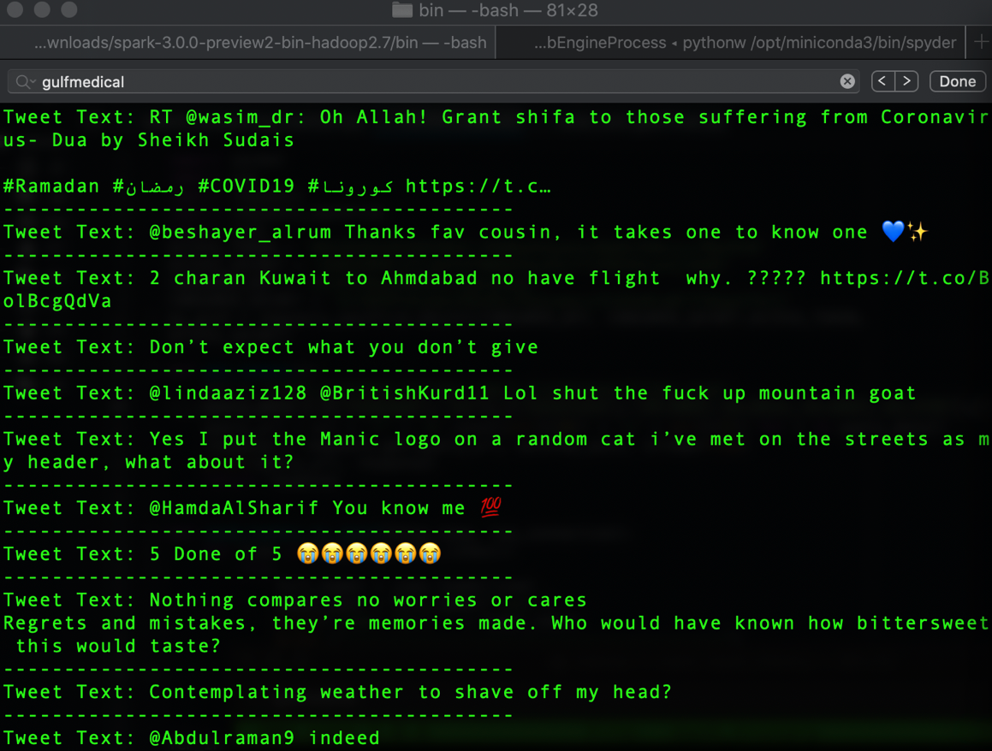

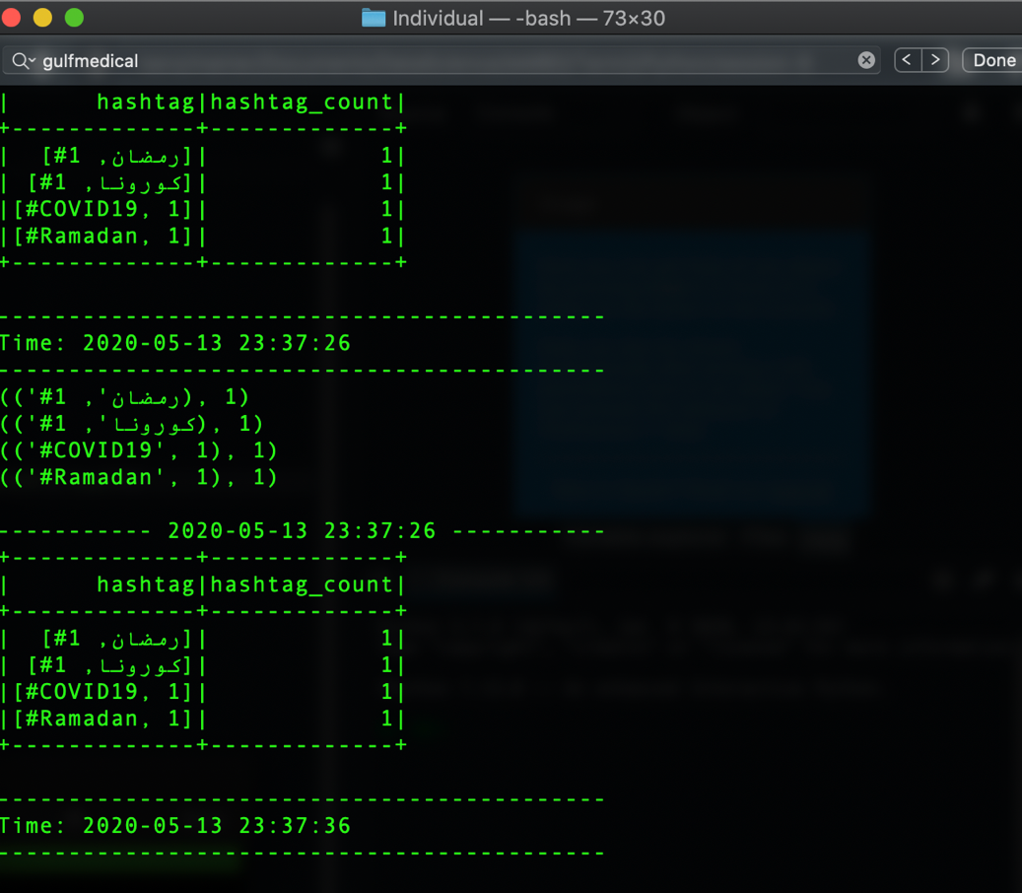

## Output of top10 elements been computed.

Answer:

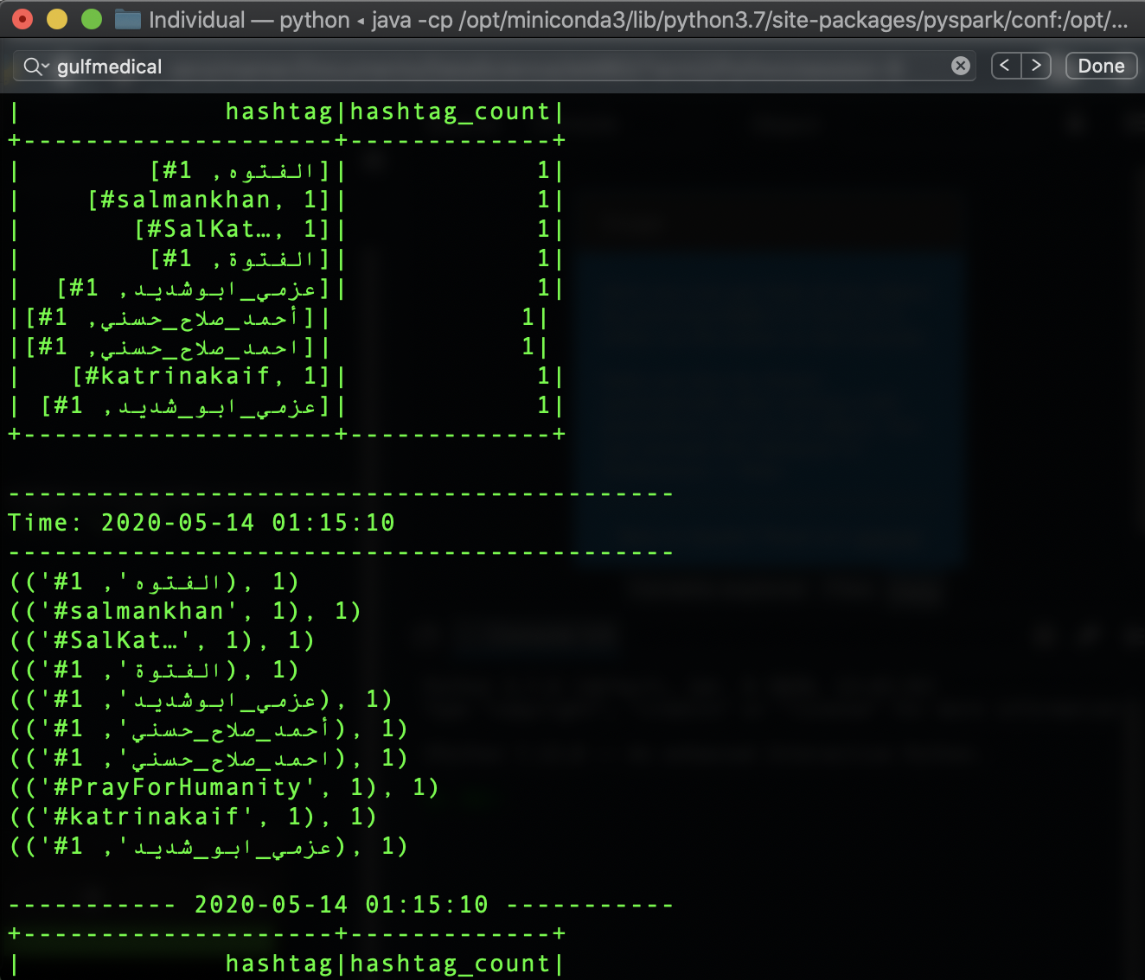

## Obtain the Top10 words (not only hashtags) using a moving window of 10 minutes every 30 seconds.

Answer: (file-🡪 spark_streaming_twitter_words.py)

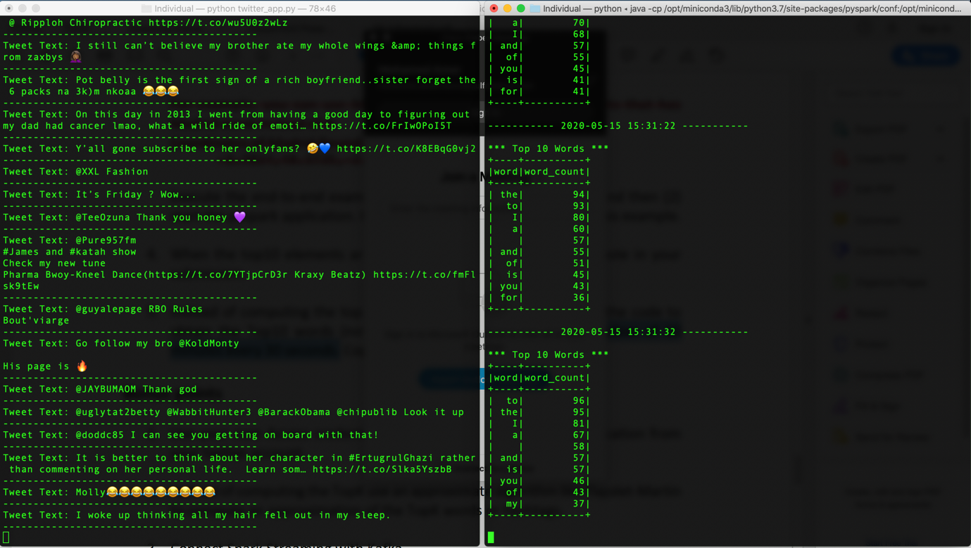

# Bonus points

## Use your own Access credentials.

Done as in point #2

## Use Flajolet-Martin algorith to compute an approximation of the TopK words or hashtags.

Answer: (file-🡪 spark_streaming_twitter_Flajolet.py)

I used Flajolet-Martin algorithm to get the total number of distinct hashtags inside the stream and since I was using a moving window of 10 minutes every 30 seconds I decided to get both of current window total distinct words and overall distinct words in separate print as shown below in my output screen

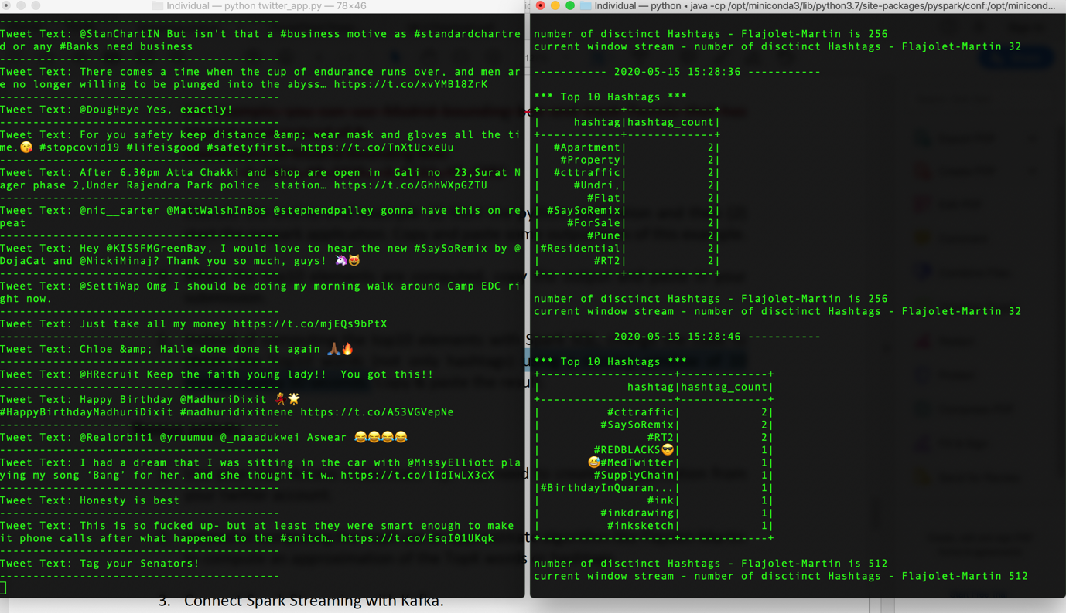

## Connect Spark Streaming with Kafka.

Answer: (files-🡪 spark_streaming_twitter_kafka.py & twitter_app_kafka.py)

bin/kafka-topics.sh --create --zookeeper localhost:2181 --replication-factor 1 --partitions 1 –topic twitter

bin/kafka-topics.sh --list --zookeeper localhost:2181

bin/kafka-console-producer.sh --broker-list localhost:9092 --topic twitter

bin/kafka-console-consumer.sh --bootstrap-server localhost:9092 --topic twitter –from-beginning

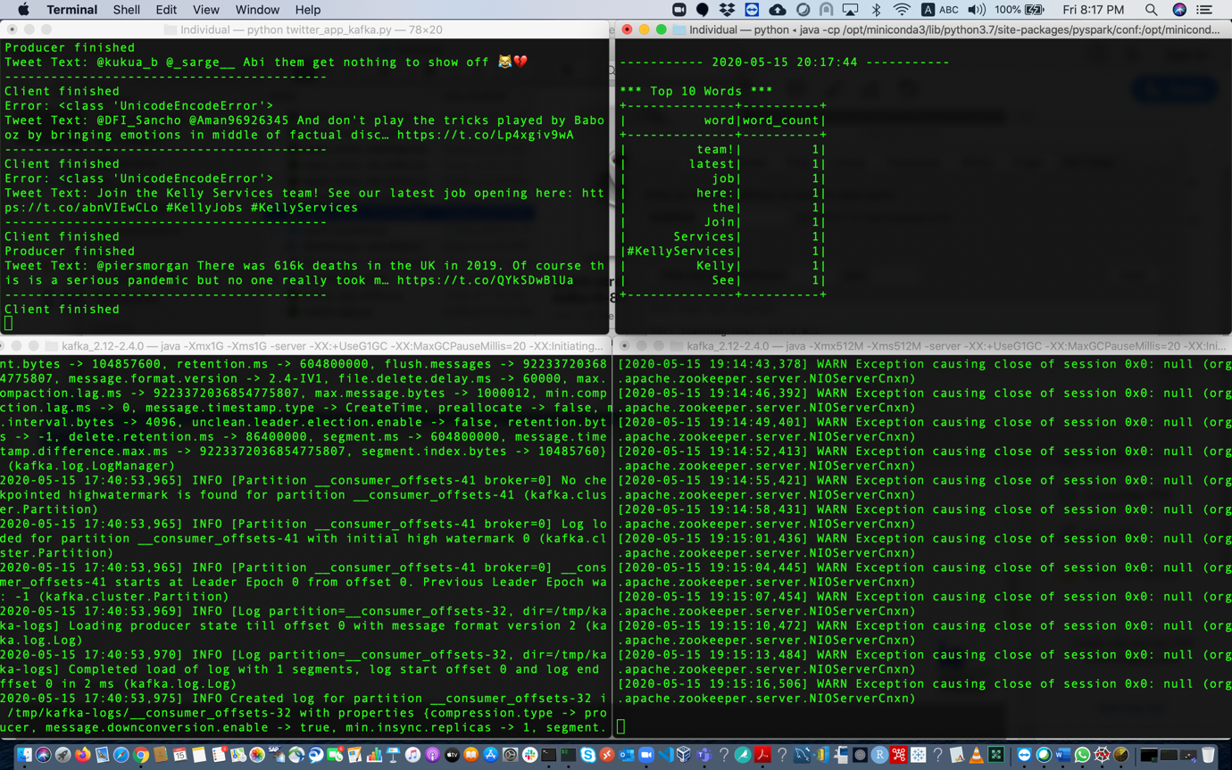

Data consumed in Kafka consumer

